Assignment 4

Solve the following problems from the textbook

 5.1-4 (a), (g), (j)

5.1-6 (a), (b) (e)

5.1-7 (a) (b) (f)

5.2.12

5.2-13 (a)

Questions:

5.1-4 (a), (g), (j)

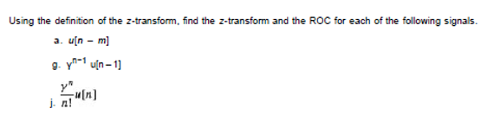

5.1-6 (a), (b) (e)

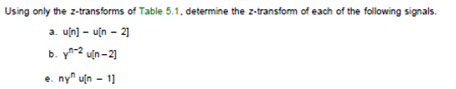

5.1-7 (a) (b) (f)

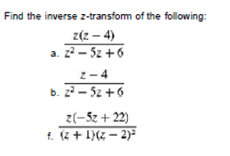

5.2.12

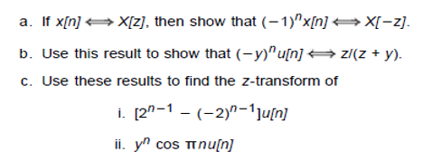

5.2-13 (a)

